Age of Empires II: Definitive Edition

Posted on January 27, 2022 by maomao

Age of Empires II: The Age of Kings is a classic real-time strategy video game developed by Ensemble Studios, published by Microsoft, and released in 1999. It is the second game in the Age of Empires series. And its definitive edition is developed by Forgotten Empires, published by Xbox Game Studios, and released in 2019. The Age of Kings is set in the Middle Ages and contains 39 playable civilizations, and the civilizations have varying strengths and weaknesses with regard to economics, technology, and combat. Players aim to create armies to defeat their enemies by gathering resources and building towns. Age of Empires II sold 2 million copies and became the best-selling product in the video game market in 7 countries in the three months it had released, and became one of the competition items in the World Cyber Games for the first three years.

Game Play

Lens 9: Elemental Tetrad

Mechanics

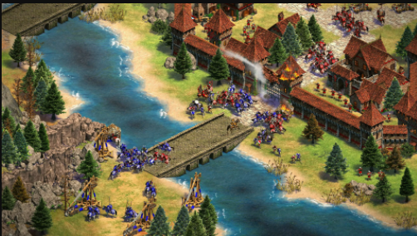

AoE2:DE 4K Frames extracted from the trailer for better visualization : r/ aoe2

The battle

Age of Empires II is a real-time strategy game that focuses on creating armies to defeat opponents. For this purpose, the player has to gather resources and build towns. Players conquer rival kingdoms as they advance one of 39 civilizations through four Ages. When advancing to a new Age, you can unlock new units, structures, and technologies.

Villagers, the Civilian units, are mainly used to gather resources or build structures. Resources can be used to train units, construct buildings, or research technologies. For instance, players can research better armor for cavalry units. The game features four types of resources: food, wood, gold, and stone. Food is obtained by hunting wild animals, gathering berries, or farming. Wood can be collected by chopping down trees. Gold and Stone mainly get from mines. Thus, the main resources are limited.

The game includes about five types of military units: infantry, archers, cavalry, siege weapons, and naval units. Certain types of infantry, archers, and cavalry are “counter units” with special defenses against other types of units. The three human classes of the military generally follow a rock-paper-scissors model. For example, the infantry are generally powerful against buildings but weak against cavalry. Thus, the infantry counter units, spearmen and pikemen, have attack bonuses against cavalry.

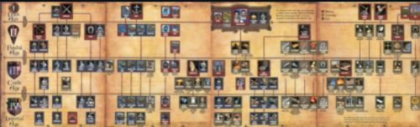

Tech Tree

Players choose to play as one of 39 civilizations. The civilizations have varying strengths and weaknesses with regard to economics, technology, and combat. Furthermore, each has access to one or more different, very powerful unique units.

Buildings in the games can research technologies and upgrades that increase economic, military, or unit-based efficiency. Also, the building can help us to defend against enemies’ attacks.

Story

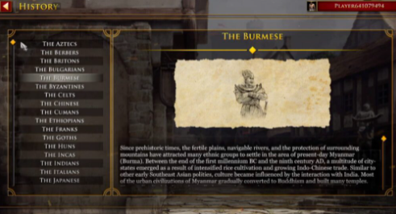

The background of civilizations

Age of Empires II is set in the Middle Ages and contains 39 playable civilizations. The entire background is adapted by the truth in history, whatever the unique unit and specialty for each civilization. For example, players who pick up “Chinese” can get three more villagers to help you to gather resources since it is famous for its agriculture. Furthermore, its single-player campaigns have multiple playable scenarios that progress a storyline, and each is centered around a different civilization. For example, in the Frankish campaign, the player leads Joan of Arc against the English in the Hundred Years’ War. All its historical stories are convincing because two professors at the University of Arizona allow gamers who play its latest game in the Age of Empires series to earn one academic credit at the university.

Aesthetics

What with its historical background and what with its new 4K graphics, Age of Empires II: Definitive Edition becomes an epic eye-catching game. Also, the game is very focused on the character’s appearance, and you can see each role of civilizations is dressed with different styles of clothes. You can enjoy the cultural diversity and the lifelike and delicate figures in the game. All the fantasy features and clothes in different cultures can be found. Furthermore, you can hear the same sentence in different languages when you choose a different civilization, that is, the role lines are customized.

Technology

The developers remake it to be accepted by 4k graphics and develop AI and trigger systems in the games to create more interactive events. Also, they update amounts of patches to make the advantages between the variety of civilizations the same and keep introducing new civilizations.

Lens 29: Chance

The game is a little bit depending on the chance. Sometimes your villagers are easier to gather resources, sometimes your rival is close to you instead of far away from you, and sometimes you have the advantage of natural barriers to defend easier. However, the main and critical factors among the players are the same because of their fairness. After all, it’s a strategy game, not a luck game.

Lens 33: Rules

Although there is some cheating code to make completing the campaign easier in single-player mode, you can’t use it when you play with others. And basically, the units you can control are almost the same as others. Since it’s a game that demands highly focusing on the screen, you can pause whenever you want but the pause has the time and the numbers limitations for fairness.

Lens 35: Head and Hands

As a tactical game, the players have to think of many strategies for different conditions. Sometimes you have to attack aggressively, and sometimes you need to defend and raid suddenly. Thus, to complete the strategy, your manipulation of the mouse and keyboard has to be precise and rapid. Furthermore, under the limited resources, how to distribute them is very critical. For example, when you focus on economics, your army will be vulnerable. Therefore, the game is not only for manipulation but also for strategy.

Lens 84: Friendship

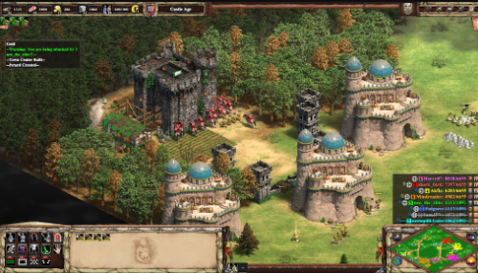

4 vs 4 battle

In the multiple-player mode, the players can cooperate with or against their friends. In other words, you can form a team, trade with one another to gain more resources, and share the resources you gather to conquer the enemies together. As a team, you can implement some complicated strategy which you can’t do alone, or you can enjoy your teamwork to defeat a mutual opponent together. On the other hand, you can choose to fight against one another and enhance your playing skill, after all, outperforming the playing skill of your friends will satisfy your ambition.

Lens 86: Community

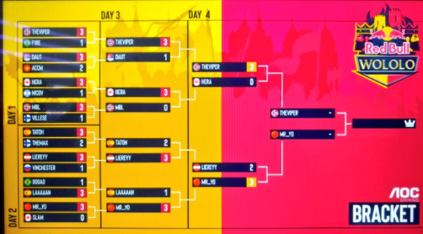

The tournament

There are many tournaments held all over the world, and there are lots of Youtubers and streamers playing with or against one another. Furthermore, when the players notice that there may be some unfairness among the civilizations, they’ll discuss it on Steam or other platforms. And the launcher will issue a patch immediately. It is not difficult to find that we form a strong community to share and talk about everything about the games. Also, you can find the player to play together.